**CREATE A CHAT BOT IN PYTHON**

**TEAM MEMBER**

**911721104023 : DHARANI S**

**Phase 4 Submission Document**

**Project:** Create a chat bot

**Phase 4:** Development Part 2

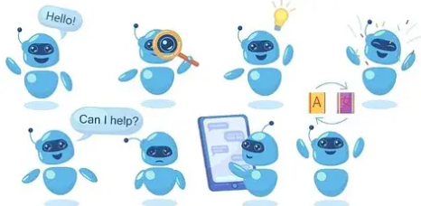

**Introduction:**

Chatbots are designed to simulate conversation with human users, making them valuable tools for businesses, websites, and applications. They can answer frequently asked questions, provide product recommendations, assist with booking services, and much more. Building a chatbot can streamline communication, increase efficiency, and ultimately enhance user engagement.

Prerequisites:

Before you begin, make sure you have a basic understanding of Python programming and some familiarity with libraries such as NLTK (Natural Language Toolkit) or spaCy, which are commonly used for natural language processing tasks. Additionally, you should be comfortable working with APIs if you plan to integrate external services into your chatbot.

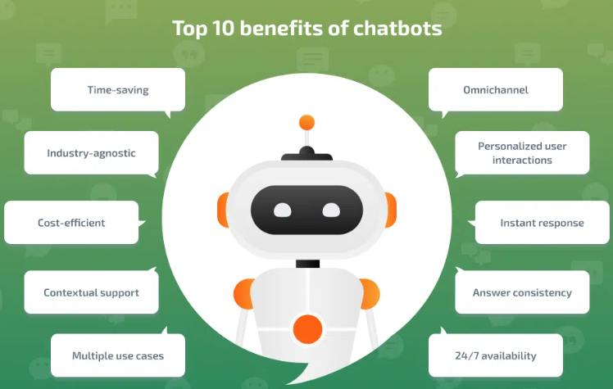

**Import Libraries**

In the first step, you import the necessary libraries for text processing and machine learning. In this example, we're using `re` for regular expressions, `nltk` for natural language processing tasks, `stopwords` from NLTK to remove common words, and `TfidfVectorizer` and `cosine_similarity` from scikit-learn for feature engineering and similarity calculations.

**Data Preprocessing**

In this step, you start with a set of sample conversations. These conversations are often stored in a database and retrieved as needed. The `preprocess_text` function is used to clean the text data. It converts the text to lowercase, removes punctuation, and extra spaces. Cleaned conversations are essential for accurate feature engineering.

**Feature Engineering**

Feature engineering is a crucial step in natural language processing tasks. In this case, TF-IDF (Term Frequency-Inverse Document Frequency) vectorization is used. TF-IDF is a numerical statistic that reflects how important a word is to a document in a collection or corpus. It's widely used for information retrieval and text mining. `TfidfVectorizer` is used to convert text data into numerical vectors, which machine learning algorithms can work with.

Feature engineering is a critical step in the process of preparing your data for machine learning. In natural language processing (NLP), it involves transforming raw text data into numerical features that machine learning algorithms can work with effectively. Here's a more detailed explanation of feature engineering in the context of NLP:

1. Tokenization:

Definition: Tokenization is the process of breaking down text into smaller units, such as words or subwords.

Importance: It helps in creating a vocabulary of words, which is essential for various NLP tasks.

2. Text Cleaning:

Definition: Text cleaning involves removing unnecessary characters, symbols, and whitespace from the text.

Importance: Clean text ensures consistent and accurate feature extraction. Common text cleaning steps include converting text to lowercase, removing punctuation, and eliminating extra spaces.

3. Stopword Removal:

Definition: Stopwords are common words (like "and", "the", "is") that do not carry significant meaning and are often removed from the text.

Importance: Removing stopwords reduces the dimensionality of the data and can improve the performance of some NLP tasks.

4. Stemming and Lemmatization:

Definition: Stemming and lemmatization are techniques used to reduce words to their base or root form.

Importance: It helps in consolidating words with similar meanings, reducing the feature space, and improving the model's ability to generalize.

5. Vectorization:

Definition: Vectorization converts text data into numerical vectors that machine learning algorithms can understand. Common methods include Bag of Words (BoW) and Term Frequency-Inverse Document Frequency (TF-IDF).

Importance: Machine learning models work with numerical data. Vectorization translates text into numerical form, preserving semantic meaning to an extent.

6. Word Embeddings:

Definition: Word embeddings are dense vector representations of words learned from large corpora using neural networks.

Importance: Unlike traditional vectorization techniques, word embeddings capture semantic relationships between words. They provide a more meaningful numerical representation of words, enabling the model to learn complex patterns.

7. Feature Extraction from Text:

Definition: Apart from raw text data, various features can be extracted, such as the length of the text, the presence of specific words or patterns, or syntactic features.

Importance: These features can provide additional context and information to the model, enhancing its ability to make predictions.

8. N-grams:

Definition: N-grams are contiguous sequences of n items (words, letters, etc.) in the text.

Importance: Including n-grams as features can capture local word patterns and improve the model's understanding of the text's structure.

**Model Training**

The model in this example is simple and rule-based. The `get_response` function takes user input, preprocesses it, converts it into a TF-IDF vector, and calculates cosine similarity with preprocessed conversation responses. Cosine similarity measures the cosine of the angle between two non-zero vectors. In this context, it measures how similar the user input is to the stored conversations. The response corresponding to the most similar conversation is selected as the chatbot's reply.



**User Interaction and Evaluation**

In the final step, the chatbot interacts with the user. It continually takes user input, calculates the most appropriate response using the trained model, and displays it to the user. The interaction continues until the user decides to exit the chat by typing "bye", "quit", or "exit".

Please note that this example is quite basic and mainly serves as an introduction to building chatbots. Real-world chatbots often involve more sophisticated techniques, including:

**Intent Recognition:** Identifying the intention behind the user's input (e.g., asking a question, seeking help, making a reservation).

**Named Entity Recognition (NER):** Identifying and classifying named entities in text into predefined categories (e.g., person names, organizations, locations).

**Dialog Management:** Handling multi-turn conversations and context to provide meaningful and contextually relevant responses.

**Response Generation:** Creating responses that are not just similar to the input but also contextually appropriate and diverse.

**User Experience:** Implementing features like error handling, polite responses, and personality traits to create a more engaging user experience.

**CONCLUSION:**

Developing a sophisticated chatbot involves a combination of these techniques and often includes leveraging machine learning models trained on large datasets and deep learning methods like sequence-to-sequence models and transformers for natural language understanding and generation tasks.